PROG8170

Programming: SQA Techniques

**Assignment #3 – Performance Testing**

**Due at the date/time specified in eConestoga for your class**

**100 Marks – worth 10%**

*This is an individual based assignment. Do your own work and do not share your work with others outside of your group. Sharing work is an Academic Offense and is subject to a penalty. Be aware that all source code and other documentation is automatically checked by eConestoga upon submission.*

For this assignment, we are going to research into a popular System/Performance Testing Tool, namely Apache JMeter to performance test a local website.

Apache JMeter

## JMeter Setup

* Ensure that you have Java 8 installed on your computer – if not, click [here.](https://www.java.com/en/download/)
* Navigate to the [“Download Apache JMeter”](https://jmeter.apache.org/download_jmeter.cgi) site and click on the .zip file found under the Binaries section:

~~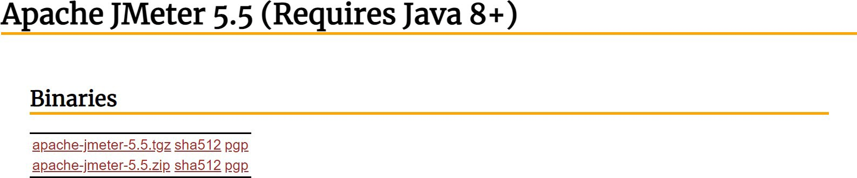~~

* Extract the files into a place on your PC’s hard drive.
* 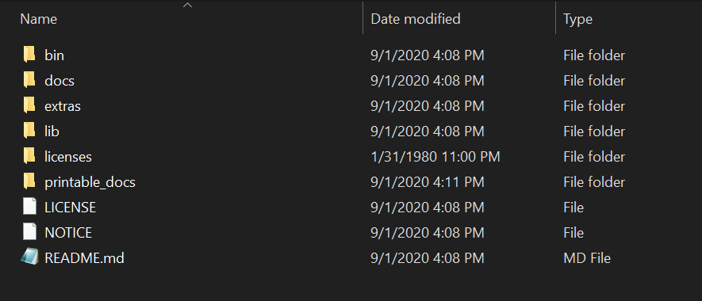You should see something similar to the following after the files have been extracted:
* Go into the ‘bin’ directory and find and double-click on the “jmeter.bat” file to start JMeter
* This will start up a command prompt as well as the JMeter UI – don’t close either, otherwise JMeter will stop
* You should now see the main JMeter UI as follows:

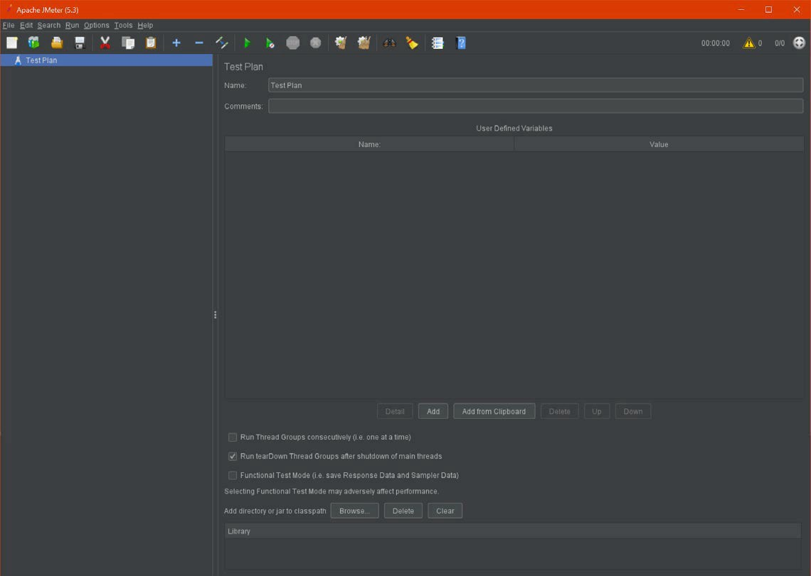

*Performance Testing*

For this assignment, we are going to research into a popular System/Performance Testing Tool, namely Apache JMeter to performance test a local website. Ensure that you have JMeter setup on your computer – for any issues around this, please review the material / videos from eConestoga.

## ~~Website Setup~~

* + Ensure that you have XAMPP installed and operational on your computer and start up the Apache Server
  + (you can review the steps of downloading / starting XAMPP from Assignment #1)

~~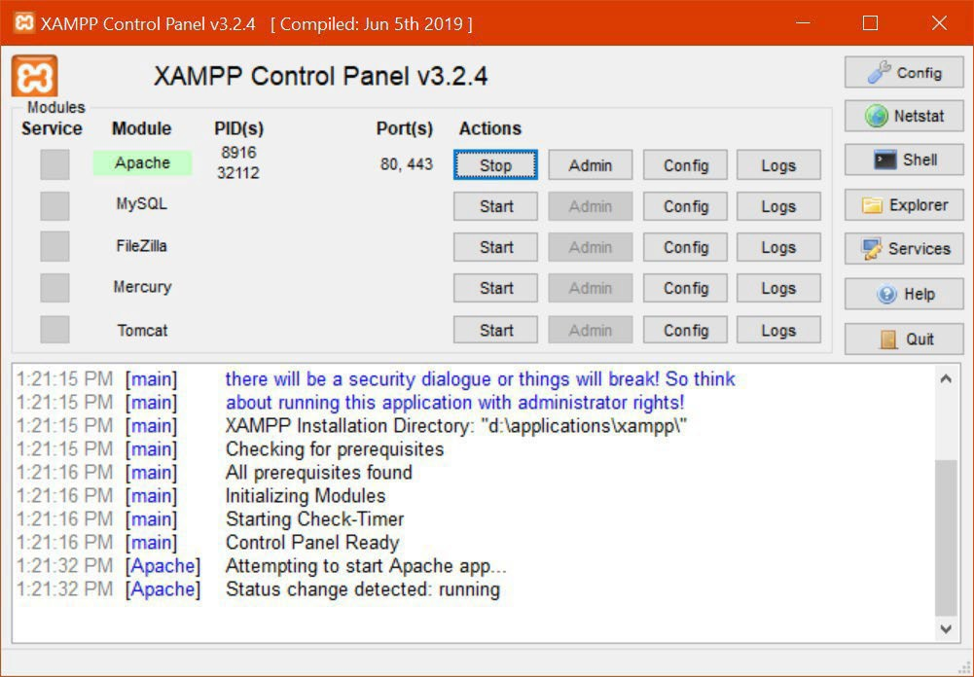~~

* + From eConestoga, download the prog2070a04.zip file to somewhere on your local hard drive
  + Extract this .zip file into the XAMPP\htdocs directory
  + You should have the following structure/files after extracting:

~~

You should now be able to access this website by going to: <http://localhost/prog8170a03/>Before proceeding, please ensure that you can access the website properly from your browser.

## Performance Testing

Add a “Thread Group” to your Test Plan within JMeter

Under the “Thread Group”, add a “Sampler” of type “HTTP Request”

Ensure that your HTTP Request is setup as follows (**Server Name or IP:** localhost and **Path:**

prog8170a03):

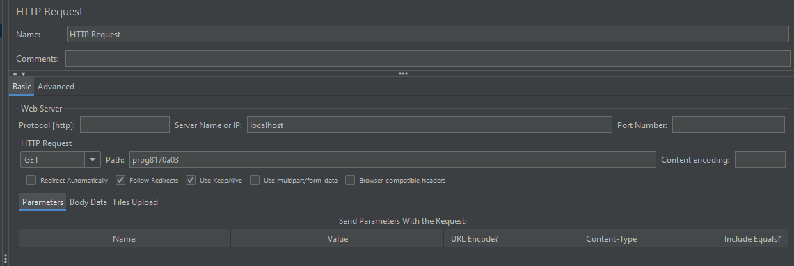

On the Advanced tab from your HTTP Request, ensure that the “Response” has a value of 5000 (you may wish to increase this to 8000 or 10000 if you receive errors in your test, especially at the higher user values), and the “Retrieve All Embedded Resources” and “Parallel downloads” options are selected:

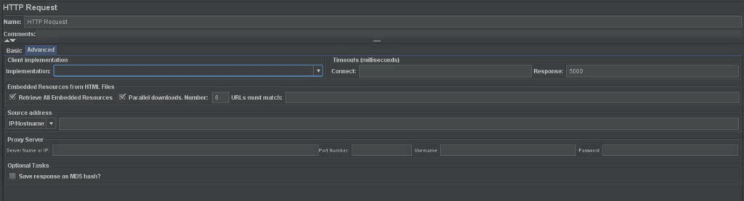

Under the HTTP Request, add a “Listener” of type “Summary Report”

Be sure to also setup and execute the Perfmon Server Agent on your PC that will monitor the CPU, and

Memory statistics. In doing so, also setup the necessary jp@gc – Perfmon Metrics Listener to capture these statistics.

Execute your test for the following number of users (individually): 1, 2, 3, 4, 5, 10, 15, 20, 25 and 50. In each case, use a “Loop Count” of 10,000. Feel free to increase the Loop Count (to 100,000 or even 1,000,000) for especially the lower number of users so that you have at least a few minutes of data captured for each test – the more data, the better. If your tests are taking more than five to ten minutes to run, you may stop the test and take the data at that time.

For each test (i.e. number of users), screen capture the screenshot of the “Summary Report” table in JMeter as well as the plot of the CPU and Memory usage. Ensure to also capture the information in the top right hand corner of the Summary Report (showing the duration of the test and the number of users used)

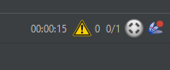

Once you have all of your data, open up MS Excel, and plot a line graph of the Average Response Time (ms) vs. Number of Users as per the accompanying video.

**Notes:**

* Keep an eye out for the Avg. Bytes as it should show a value about ~6.6MB as well as your Error count should be as low as possible (it should be less than ~3%) especially at the larger user values. If you don’t see such values, recheck to ensure that you have followed the setup procedure.
* If you are unable to save your .jmx file, try changing your theme under Options | Look and Feel to a Windows theme and retry saving
* If your Server Agent is shutting down upon startup, ensure that it is installed in directory that you have access to (installing directly into the Downloads folder has in the past caused such errors – as such, try installing it into a directory like C:\Applications\ServerAgent, etc…)
* If you are getting errors with the ServerAgent shutting down when the test is running, ensure that you’ve copied over the sigar-amd64-winnt.dll file from eConestoga into the lib/ folder of where you have installed the Server Agent.
* In case of any other issues, please review the three videos in eConestoga regarding the setup of JMeter and the ServerAgent as well as how to run performance tests.

# Submissions

The format for submitting the assignment is as follows:

1. eConestoga submissions:
   * A single MS Word document named: **FirstName_LastName_StudentID_Assignment3.docx** Where FirstName, LastName and StudentID are your particulars that contains (in order):
2. ~~Assignment Title Page with your name, student ID, “Assignment #4” in the title and date;~~
3. Screenshots for the “Summary Report” and CPU/MEM graphs for each test

# [60 Marks]

1. An MS Excel chart showing the Average Response Time vs. Number of Users with the correct axes, titles and graph that is embedded into the MS Word document. DO NOT SUBMIT THE EXCEL FILE FOR THIS PORTION.

# [20 Marks]

1. An explanation of your results including what element(s) on this website could lead to a performance bottleneck. Be sure to discuss your results based **only** using the data obtained from your tests. Also, be sure to discuss the validity of the results based on this setup and what factors could influence the performance of the website when it’s released.

# [15 Marks]

* + The corresponding .jmx file that was used for your last test (using 50 users) – submitted as a separate upload from the .docx file. Please name it using the format specified above (for the .docx file) but with the .jmx extension.

# [5 Marks]

Please submit the above two files to the **“Assignment 03”** assignment folder in eConestoga.

**Late penalties will apply for any late submissions.**

**A -10% penalty will be applied for any files that are zipped up or not using the correct naming format.**

**As this is a technical report, proper spelling and grammar will also be required and marks may be lost for reports that have poor spelling and / or grammar. A more detailed marking scheme is shown in the Rubric associated with the Assignment Folder in eConestoga.**